Choose property “ ”

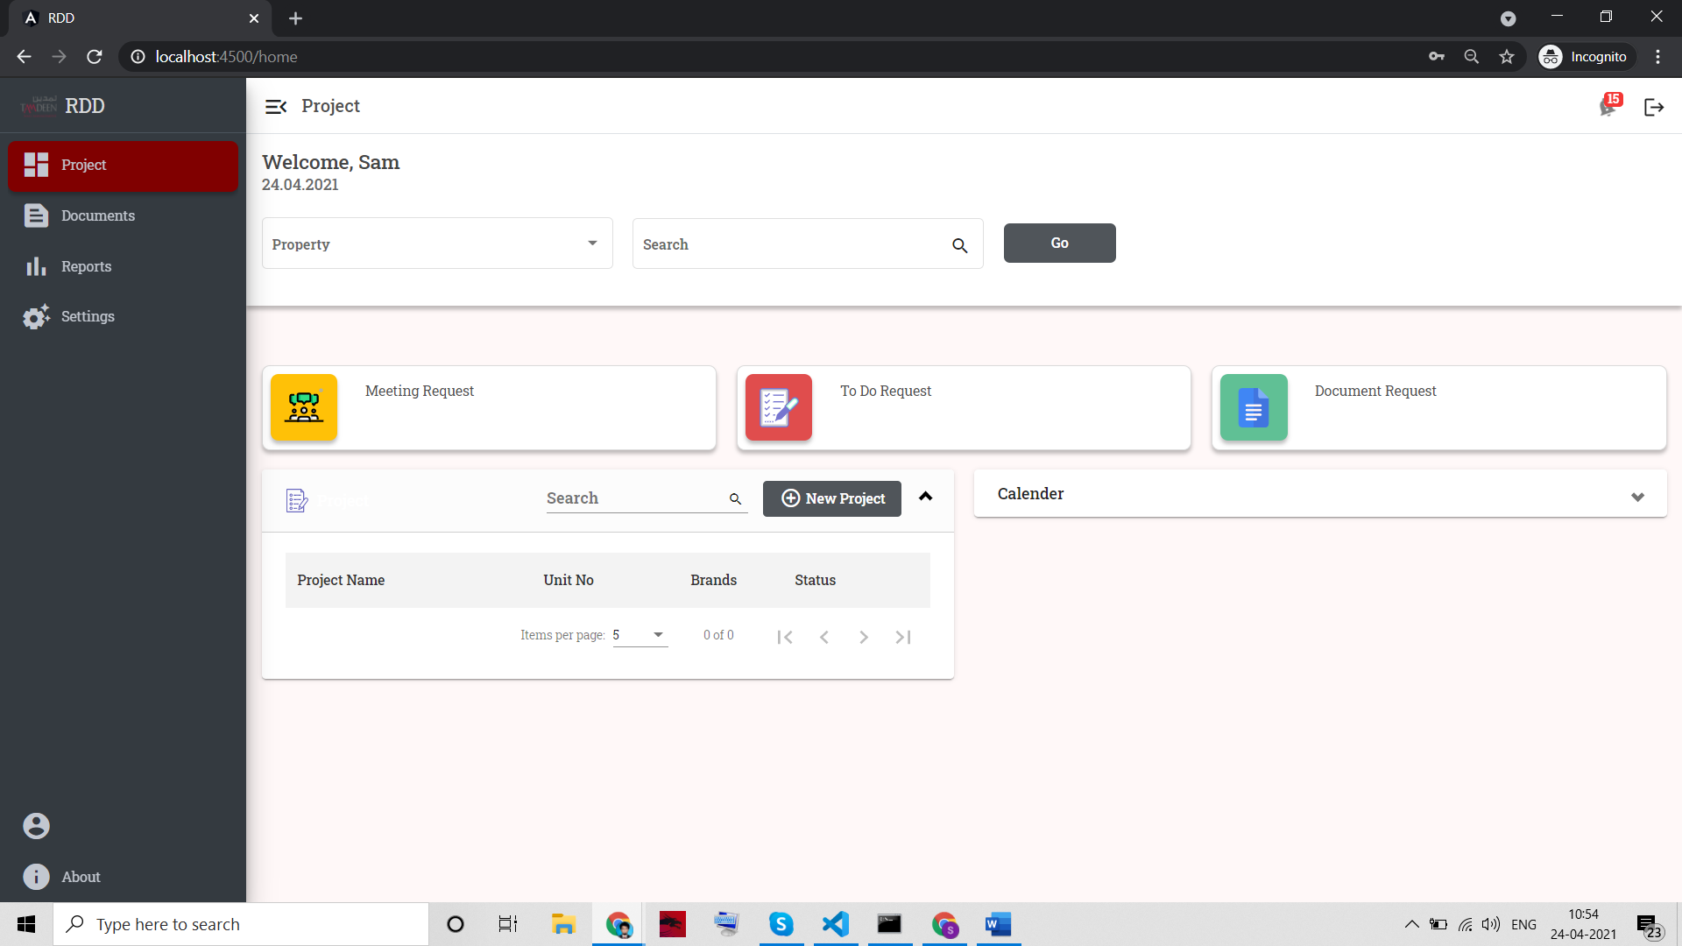

Click on Meeting Request

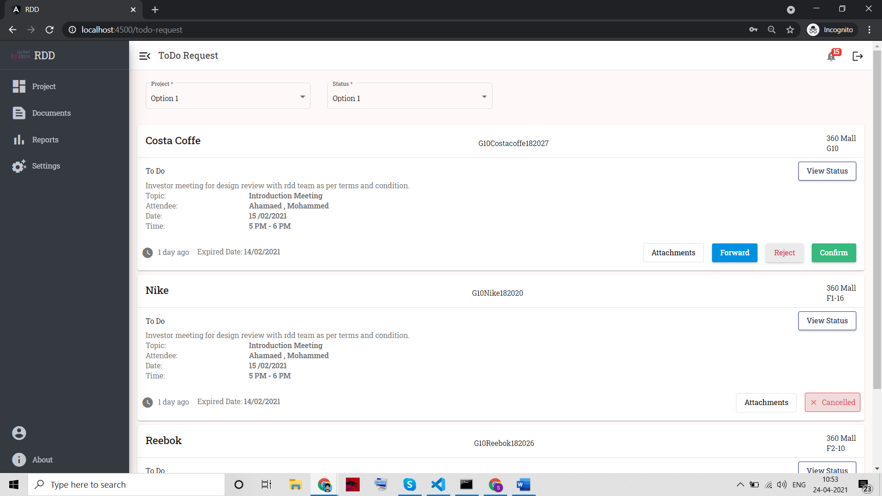

Getting task list based on task type, In this API, we need to pass Task type = 1

API NO – 140

**/project/tasklist/{tasktype}/{memid}/{memname}**

**Tasktype: 1-meeting, 2-document, 3-todo**

**Pass 1 as we are getting meeting task**

* Memid, memname can be retrieved in login response. Pass

User_id -> memid

first_name ->memname

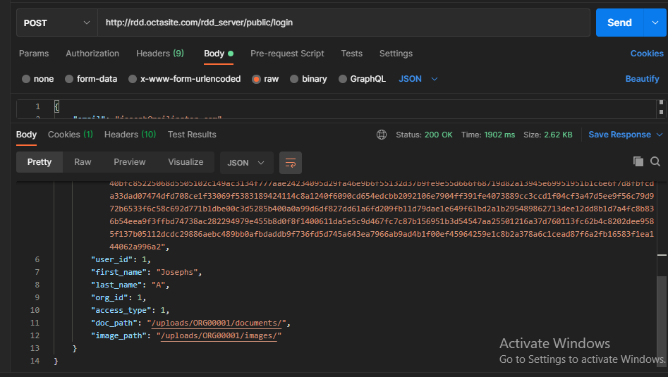

Response on calling API 140 – Task list.

[

{

"id": 155,

"org_id": 1,

"project_id": 80,

"template_id": 3,

"template_master_id": 14,

"task_type": 3,

"activity_desc": "Updated RDD meet investors about kicking off the project updated content",

"meeting_topic": null,

"meeting_date": "2021-06-02",

"meeting_start_time": "14:00:00",

"meeting_end_time": "16:00:00",

"approvers": "12",

"approvers_designation": "4",

"attendees": "20-George",

"attendees_designation": "5,7",

"phase_id": 1,

"mem_responsible": "22,24",

"mem_responsible_designation": "2,3",

"fre_id": 1,

"duration": 2,

"seq_status": 0,

"seq_no": 1,

"planned_date": "2021-06-04 00:00:00",

"actual_date": null,

"fif_upload_path": "testpath/path",

"created_at": "2021-04-16 09:59:55",

"updated_at": "2021-04-16 10:20:38",

"created_by": 22,

"isProjecttask": 0,

"isForwarded": 0,

"task_status": 7,

"isDeleted": 0,

"property_name": "Khiran",

"project_name": "F02 starbucks"

}

]

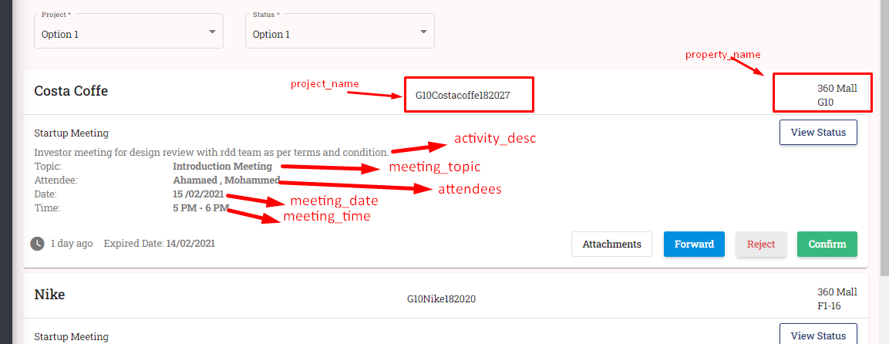

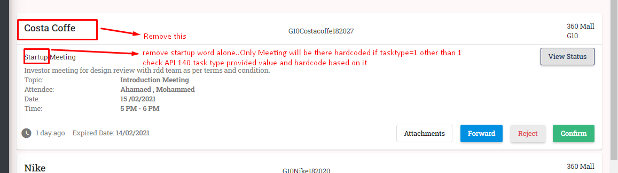

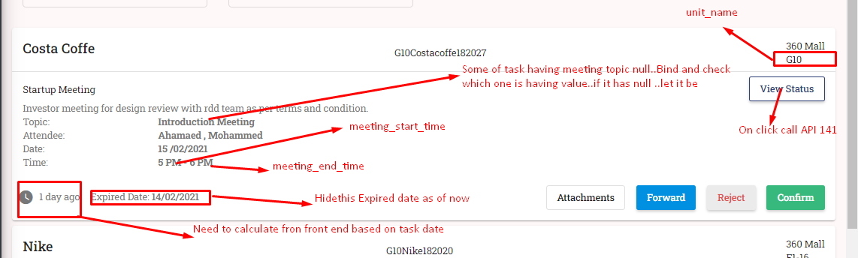

**API – 141** for getting approvers for task and their approval Status

/project/approvalstatus/{projectid}/{taskid}

Projectid -> get from API 140 response "project_id": 80,

taskid -> -> get from API 140 response "id": 155,

Response will be,

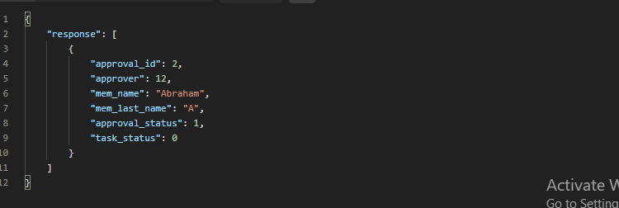

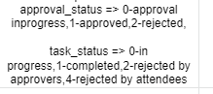

Bind the response in below drawer, and based on approval status value from response, do use status color like below

